**Grid Assignment**

1. **Create an image gallery using a CSS grid.**

**Ans: HTML Code:**

**<!DOCTYPE html>**

**<html lang="en">**

**<head>**

**<meta charset="UTF-8">**

**<meta name="viewport" content="width=device-width, initial-scale=1.0">**

**<title>Grid Layout</title>**

**<link rel="stylesheet" href="style.css">**

**</head>**

**<body>**

**<div class="grid-container">**

**<img src="image1.jpg" alt="Image 1" class="item1">**

**<img src="image2.jpg" alt="Image 2" class="item2">**

**<img src="image3.jpg" alt="Image 3" class="item3">**

**<div class="combined">**

**<img src="image4.jpg" alt="Image 4" class="item4">**

**<img src="image5.jpg" alt="Image 5" class="item5">**

**</div>**

**<img src="image6.jpg" alt="Image 6" class="item6">**

**</div>**

**</body>**

**</html>**

**CSS Code:**

**body {**

**display: flex;**

**justify-content: center;**

**align-items: center;**

**height: 100vh;**

**margin: 0;**

**font-family: 'Times New Roman', Times, serif;**

**}**

**.grid-container {**

**display: grid;**

**grid-template-columns: repeat(3, 1fr);**

**grid-template-rows: auto auto;**

**gap: 10px;**

**width: 80%;**

**max-width: 800px;**

**border: 2px solid black;**

**padding: 10px;**

**}**

**.item1 {**

**grid-column: span 2;**

**width: 500px;**

**height: 165px;**

**}**

**.item2 {**

**grid-column: 3 / 4;**

**width: 290px;**

**height: 170px;**

**margin-right: 40px;**

**}**

**.item3 {**

**grid-column: 1 / 2;**

**grid-row: 2 / 3;**

**width: 250px;**

**height: 230px;**

**}**

**.combined {**

**display: grid;**

**grid-template-rows: 1fr 1fr;**

**grid-row: 2 / 3;**

**grid-column: 2 / 3;**

**}**

**.item4,**

**.item5 {**

**width: 97.5%;**

**height: 110px;**

**}**

**.item5 {**

**margin-top: 5px;**

**}**

**.item6 {**

**grid-column: 3 / 4;**

**grid-row: 2 / 3;**

**width: 285px;**

**height: 230px;**

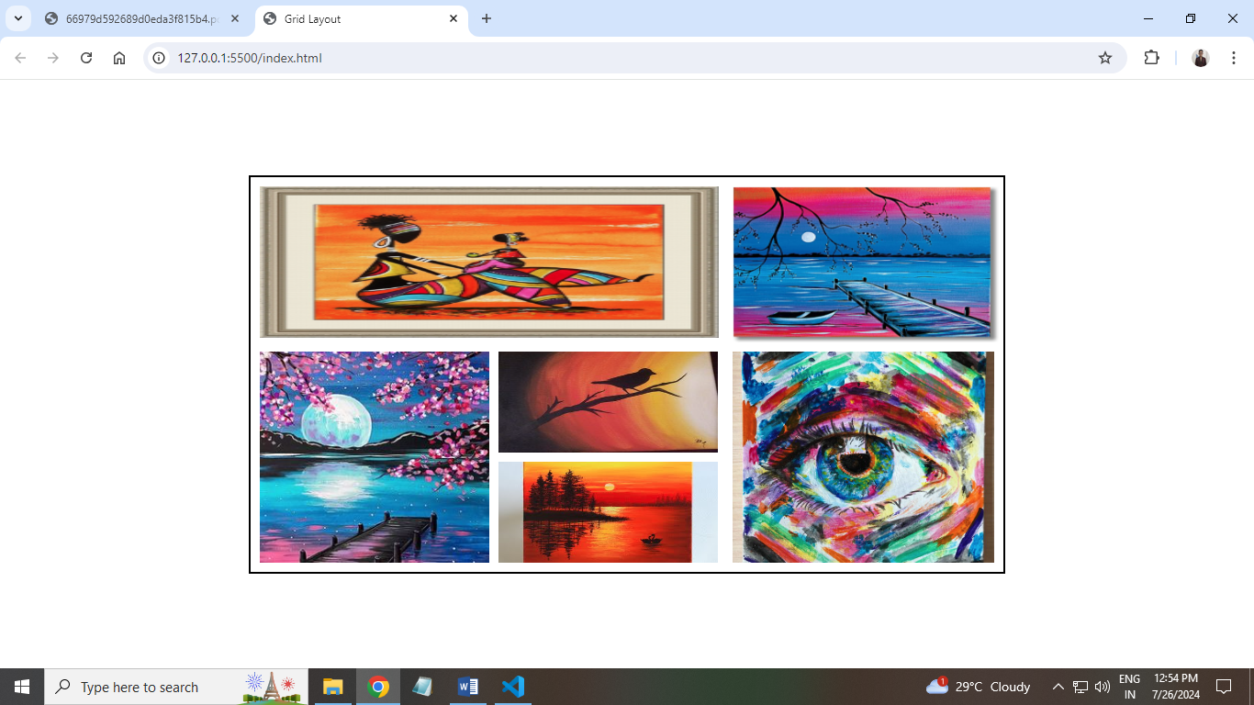**}**

1. **Write code to arrange containers with texts A, B, C, and D as shown in the below image.**

**Ans: HTML Code:**

**<!DOCTYPE html>**

**<html lang="en">**

**<head>**

**<meta charset="UTF-8">**

**<meta name="viewport" content="width=device-width, initial-scale=1.0">**

**<link rel="stylesheet" href="style.css">**

**<title>Grid Layout</title>**

**</head>**

**<body>**

**<div class="grid-container">**

**<div class="grid-item item-a">A</div>**

**<div class="grid-item item-b">B</div>**

**<div class="grid-item item-c">C</div>**

**<div class="grid-item item-d">D</div>**

**</div>**

**</body>**

**</html>**

**CSS Code:**

**html,**

**body {**

**display: flex;**

**justify-content: center;**

**align-items: center;**

**height: 100vh;**

**margin: 0;**

**font-family: 'Times New Roman', Times, serif;**

**}**

**.grid-container {**

**display: grid;**

**grid-template-columns: repeat(3, 1fr);**

**grid-template-rows: repeat(2, 1fr);**

**gap: 10px;**

**width: 400px;**

**height: 200px;**

**}**

**.item-a {**

**grid-column: span 2;**

**background-color: lightcoral;**

**}**

**.item-b {**

**grid-row: span 2;**

**background-color: lightblue;**

**}**

**.item-c {**

**background-color: lightgreen;**

**}**

**.item-d {**

**background-color: lightgoldenrodyellow;**

**}**

**.grid-item {**

**display: flex;**

**align-items: center;**

**justify-content: center;**

**font-size: 24px;**

**font-weight: bold;**

**}**

1. 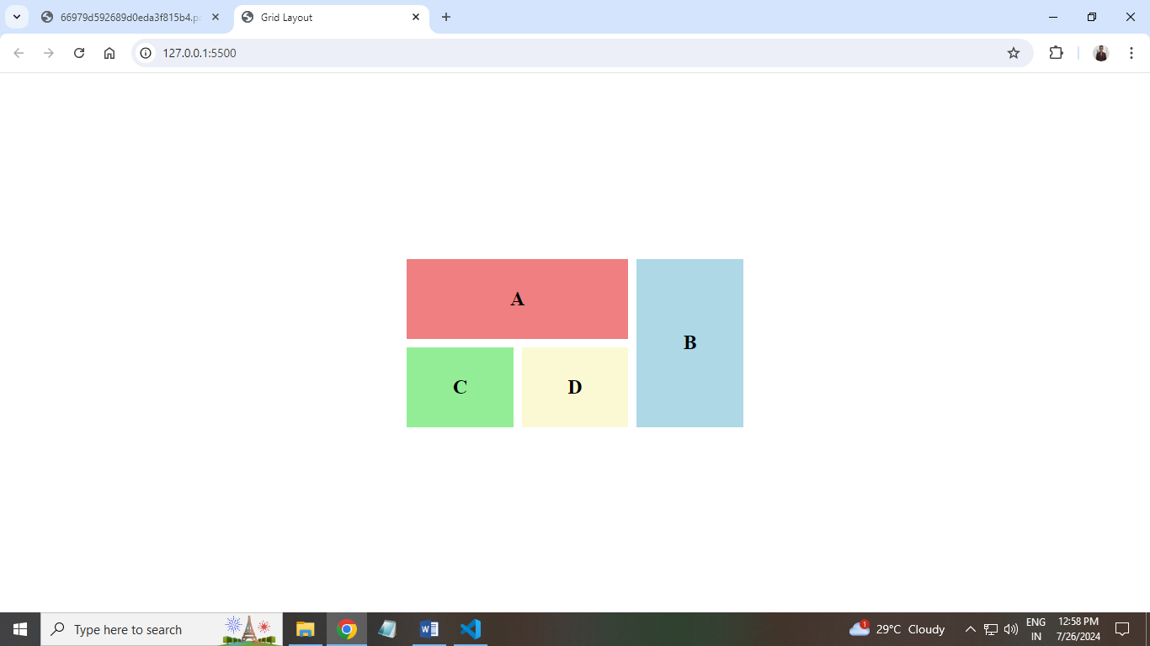**Explain the use of grid-auto-row and grid-auto-column using code examples.**

**Ans: Introduction to Grid Auto Row and Column:**

* **grid-auto-rows and grid-auto-columns are properties in CSS Grid Layout used to define the size of rows and columns that are created implicitly. When you create a grid and add more items than the specified rows or columns can handle, CSS Grid will automatically create additional rows or columns to accommodate the extra items. The grid-auto-rows and grid-auto-columns properties specify the size of these additional rows or columns.**
* **Example of Grid Auto Row:**

**<!DOCTYPE html>**

**<html lang="en">**

**<head>**

**<meta charset="UTF-8">**

**<meta name="viewport" content="width=device-width, initial-scale=1.0">**

**<title>grid-auto-rows Example</title>**

**<style>**

**.grid-container {**

**display: grid;**

**grid-template-columns: 100px 100px;**

**grid-auto-rows: 50px;**

**gap: 10px;**

**}**

**.grid-item {**

**background-color: lightblue;**

**border: 1px solid blue;**

**text-align: center;**

**padding: 20px;**

**}**

**</style>**

**</head>**

**<body>**

**<div class="grid-container">**

**<div class="grid-item">1</div>**

**<div class="grid-item">2</div>**

**<div class="grid-item">3</div>**

**<div class="grid-item">4</div>**

**<div class="grid-item">5</div>**

**</div>**

**</body>**

**</html>**

* **Grid Auto Columns Example:**

**<!DOCTYPE html>**

**<html lang="en">**

**<head>**

**<meta charset="UTF-8">**

**<meta name="viewport" content="width=device-width, initial-scale=1.0">**

**<title>grid-auto-columns Example</title>**

**<style>**

**.grid-container {**

**display: grid;**

**grid-template-rows: 100px 100px;**

**grid-auto-columns: 50px;**

**gap: 10px;**

**}**

**.grid-item {**

**background-color: lightgreen;**

**border: 1px solid green;**

**text-align: center;**

**padding: 20px;**

**}**

**</style>**

**</head>**

**<body>**

**<div class="grid-container">**

**<div class="grid-item">1</div>**

**<div class="grid-item">2</div>**

**<div class="grid-item">3</div>**

**<div class="grid-item">4</div>**

**<div class="grid-item">5</div>**

**</div>**

**</body>**

**</html>**

1. **Write CSS to show numbers as shown in the figure, without altering the below html code.**

**<!DOCTYPE html>**

**<html lang="en">**

**<head>**

**<meta charset="UTF-8">**

**<meta name="viewport" content="width=device-width, initial-scale=1.0">**

**<link rel="stylesheet" href="style.css">**

**<title>Grid Boxes</title>**

**</head>**

**<body>**

**<div class="container">**

**<div class="box box1">1</div>**

**<div class="box box2">2</div>**

**<div class="box box3">3</div>**

**<div class="box box4">4</div>**

**<div class="box box5">5</div>**

**<div class="box box6">6</div>**

**<div class="box box7">7</div>**

**<div class="box box8">8</div>**

**</div>**

**</body>**

**</html>**

**CSS Code:**

**.container {**

**display: grid;**

**grid-template-columns: repeat(6, 0.2fr);**

**grid-template-rows: repeat(2, 1fr);**

**}**

**.box {**

**display: flex;**

**justify-content: center;**

**align-items: center;**

**height: 70px;**

**font-size: 2em;**

**border-radius: 5px;**

**width: 50%;**

**box-sizing: border-box;**

**height: 90px;**

**}**

**.box1 {**

**grid-area: 2 / 1 / 3 / 2;**

**background-color: black;**

**color: white;**

**margin-top: 5px;**

**}**

**.box2 {**

**grid-area: 2 / 2 / 3 / 3;**

**background-color: grey;**

**margin-top: 5px;**

**}**

**.box3 {**

**grid-area: 1 / 1 / 2 / 2;**

**background-color: black;**

**color: white;**

**}**

**.box4 {**

**grid-area: 1 / 2 / 2 / 3;**

**background-color: grey;**

**}**

**.box5 {**

**grid-area: 1 / 3 / 2 / 4;**

**background-color: black;**

**color: white;**

**}**

**.box6 {**

**grid-area: 1 / 4 / 2 / 5;**

**background-color: grey;**

**}**

**.box7 {**

**grid-area: 1 / 5 / 2 / 6;**

**background-color: black;**

**color: white;**

**}**

**.box8 {**

**grid-area: 1 / 6 / 2 / 7;**

**background-color: grey;**

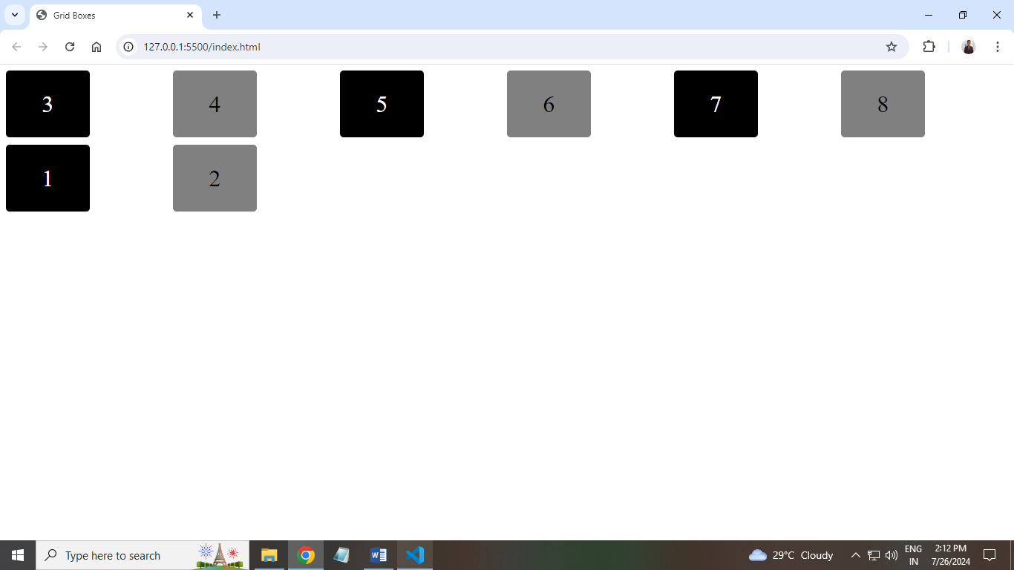**}**

1. **Explain the difference between justify-items and justify-self using code examples.**

**Ans: Introduction to justify-items and justify-self:**

* **In CSS Grid, justify-items and justify-self are used to align grid items along the inline (row) axis. They control the positioning of the content within the grid items.**
* **Example Code of justify-items:**

**<!DOCTYPE html>**

**<html lang="en">**

**<head>**

**<meta charset="UTF-8">**

**<meta name="viewport" content="width=device-width, initial-scale=1.0">**

**<title>Justify Items Example</title>**

**<style>**

**.grid-container {**

**display: grid;**

**grid-template-columns: repeat(3, 1fr);**

**grid-template-rows: 100px;**

**justify-items: center; /* Center all items */**

**gap: 10px;**

**border: 1px solid black;**

**}**

**.grid-item {**

**background-color: lightblue;**

**padding: 20px;**

**border: 1px solid blue;**

**}**

**</style>**

**</head>**

**<body>**

**<div class="grid-container">**

**<div class="grid-item">Item 1</div>**

**<div class="grid-item">Item 2</div>**

**<div class="grid-item">Item 3</div>**

**</div>**

**</body>**

**</html>**

* **Example Code of justify-self:**

**<!DOCTYPE html>**

**<html lang="en">**

**<head>**

**<meta charset="UTF-8">**

**<meta name="viewport" content="width=device-width, initial-scale=1.0">**

**<title>Justify Self Example</title>**

**<style>**

**.grid-container {**

**display: grid;**

**grid-template-columns: repeat(3, 1fr);**

**grid-template-rows: 100px;**

**gap: 10px;**

**border: 1px solid black;**

**}**

**.grid-item {**

**background-color: lightblue;**

**padding: 20px;**

**border: 1px solid blue;**

**}**

**.item1 {**

**justify-self: start;**

**}**

**.item2 {**

**justify-self: center;**

**}**

**.item3 {**

**justify-self: end;**

**}**

**</style>**

**</head>**

**<body>**

**<div class="grid-container">**

**<div class="grid-item item1">Item 1</div>**

**<div class="grid-item item2">Item 2</div>**

**<div class="grid-item item3">Item 3</div>**

**</div>**

**</body>**

**</html>**